Finding Strength in Faith
Exploring How Spiritual Practices Support Mental Wellness and Provide Comfort During Difficult Times
Spirituality and faith have been central sources of comfort and resilience for people around the world for centuries. Whether through prayer, meditation, communal worship, or meaning‑making frameworks, spiritual practices can help individuals cope with stress, reduce anxiety, and find hope in challenging moments. Today, scientific research increasingly confirms that spirituality isn’t just a matter of belief — it can also play a meaningful role in mental well‑being and emotional health when integrated thoughtfully into a person’s life.
In this article, we’ll explore how spiritual practices support mental wellness, how they can be woven into daily life, and practical steps you can take — all while drawing on both research and real‑life experience in a culturally sensitive way, including Jamaican examples where appropriate.

What Does “Spirituality” Mean in Mental Wellness?
At its core, spirituality involves seeking meaning, purpose, connection, and transcendence — a sense of being part of something larger than oneself. It can be rooted in organized religion, personal belief systems, or even secular spiritual practices. Spirituality differs from simply following routines; it touches on deep values and emotional experiences that shape how people interpret life events.
Research shows that religious and spiritual engagement is positively associated with life satisfaction, meaning in life, and improved social relationships, while often correlating with lower levels of anxiety and depressive symptoms.
Faith, therefore, can act as both a cognitive resource (meaning‑making and interpretation) and an emotional anchor (providing hope, comfort, and community).

How Faith and Spiritual Practices Benefit Mental Health

https://pixabay.com/illustrations/relaxation-meditation-health-7282116/
Spiritual and faith‑based practices support mental wellness in several scientifically documented ways:

🧠 1. Meaning and Purpose in Hard Times
Many people use faith to interpret life stressors through a lens of meaning — seeing challenges as part of a larger story rather than random misfortune. This process is known to reduce distress and improve emotional resilience because it helps individuals make sense of adversity rather than feel overwhelmed by it.
In Jamaican life, for example, a family member might draw strength from believing that difficulties have spiritual significance (“Mi going through dis but God nah lef mi”), which can provide a sense of purpose and lessen feelings of hopelessness.

❤️ 2. Community and Social Support
Spiritual communities — whether church groups, prayer circles, or fellowship gatherings — provide powerful social support, which is a protective factor against anxiety, depression, and isolation. Being part of a community reinforces a sense of belonging and shared experience, reminding individuals they are not alone.
In Jamaica, community support often comes through weekly church services, choir groups, or small group gatherings that blend social connection with spiritual support.

🌬️ 3. Practices That Calm the Mind
Certain spiritual practices mirror psychological techniques like mindfulness and meditation, which have been well researched for their mental health benefits. These include:
- Prayer and contemplative reflection
- Breath‑focused meditation
- Loving‑kindness or compassionate prayer
- Singing ancestral hymns or spiritual music
Studies suggest that meditation and reflective practices can reduce stress hormones like cortisol, support emotional regulation, and enhance psychological well‑being.
Jamaican examples could include quiet reflection with Reggae gospel, singing praise songs at home, or journaling spiritual gratitude each morning without distraction.

🌟 4. Hope and Coping with Loss
Faith can offer tools to cope with grief, loss, or major life transitions. Beliefs about divine purpose or the afterlife, as well as ritual practices such as prayer or reading scripture, can provide profound comfort and emotional processing. This helps individuals move through grief rather than feeling stuck in overwhelming sorrow.

Research Behind Spiritual Coping
A body of scientific research supports these mental health benefits:
- A large systematic analysis of nearly 79,000 participants found that rich religious/spiritual life was negatively associated with anxiety and depression and positively associated with life satisfaction and overall well‑being.
- Qualitative research among aid workers in stressful environments found that faith and spirituality were important psychological coping mechanisms linked to reduced distress and better psychological adjustment.
- Scientific reviews also highlight that prayer, meditation, and ritual participation frequently align with reductions in stress and give individuals a sense of belonging and identity.
Together, these findings suggest that faith and spirituality are more than subjective feelings — they have real psychological effects that help people manage distress and build resilience.

Practical Spiritual Practices for Mental Wellness
Below are some spiritual practices that many people — including Jamaicans — find uplifting and beneficial for mental health. You can adapt these to your personal beliefs and lifestyle:

✨ 1. Daily Reflection or Prayer
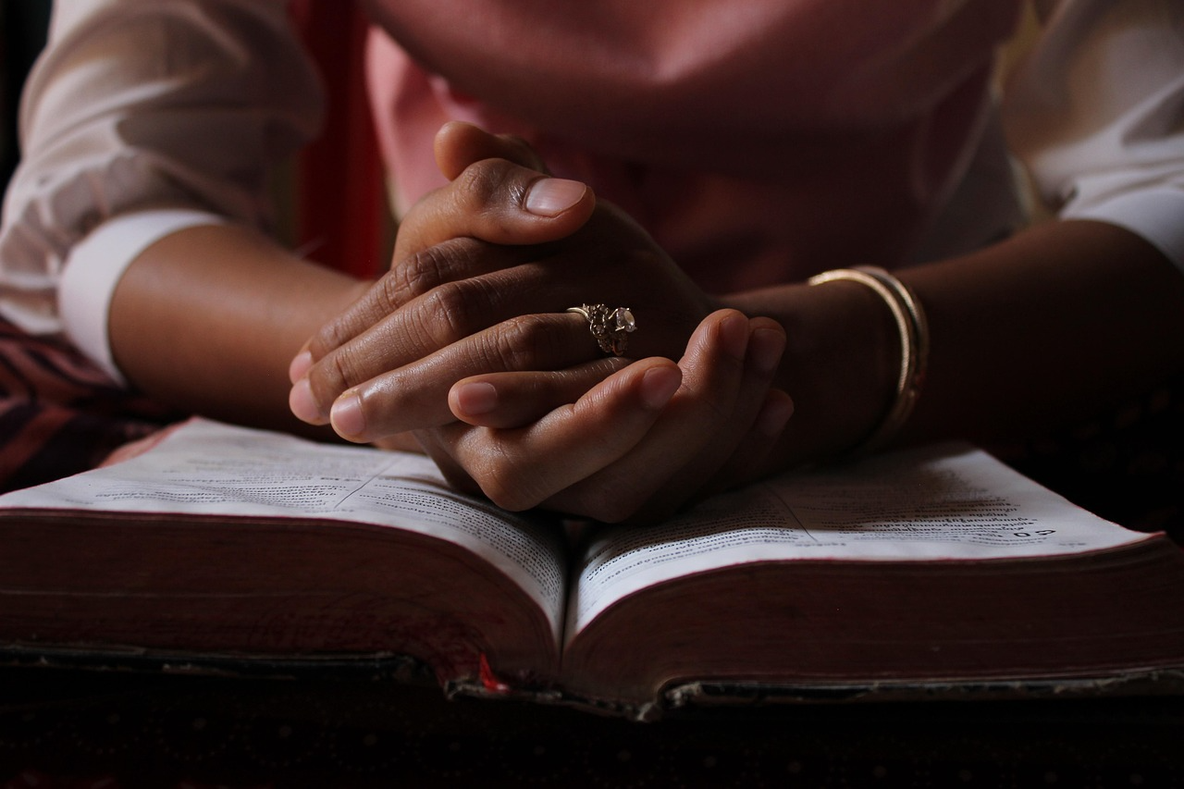
https://pixabay.com/photos/praying-bible-reading-bible-worship-5406270/
- Set aside 5–10 minutes to focus your thoughts, express gratitude, or pray for strength.
- Use this time to acknowledge feelings without judgment.
Example practice:
“Today, I give thanks for three blessings: good health, family, and peace of mind.”

🌿 2. Scripture or Inspirational Reading
- Reading meaningful passages can nourish the soul and provide perspective.
- Consider texts that emphasize peace, resilience, or purpose.
Example Jamaican context:
Many Jamaicans find comfort in passages like Psalm 23 or Philippians 4:6‑7, which encourage peace in anxious times.

🎵 3. Spiritual Music or Hymns
Listening to spiritual or religious music can be calming and emotionally grounding. In Jamaica, gospel reggae or church choir music can be especially comforting, offering both melody and meaning.

🤲 4. Gratitude Journaling
Write down things you’re grateful for each day — spiritual or secular. This simple practice strengthens awareness of blessings and shifts focus away from worry.

🕯️ 5. Meditative Prayer or Contemplation
Even if not formally religious, contemplative prayer (quiet, focused reflection on inner experience and values) can reduce stress and sharpen emotional clarity. Concepts from mindfulness meditation overlap with this practice and benefit mental well‑being.

Spiritual Wellness and Connection
Spiritual practices often work through connection — connection with self, with others, with a transcendent reality, or with community. Research shows that when people feel connected and supported, the emotional brain responds with greater resilience and less fear reactivity.
Even outside formal religion, spiritual values like compassion, forgiveness, and service contribute to healthier emotional regulation and deeper purpose.

How to Begin Your Spiritual Wellness Routine
You don’t need to overhaul your life. Start small:
- Set a daily moment of quiet (5–10 mins)
- Practice gratitude
- Participate in community worship if you desire
- Use music or scripture for comfort
- Reflect on meaning and purpose
Make the practice your own — what matters most is consistency, not perfection.

Things to Remember
- Spiritual practices can complement mental health support, not replace professional help.
- If you’re struggling with severe anxiety, depression, or distress, seek support from a mental health professional alongside spiritual practices.

🌟 Everyday Spiritual Exercise
Try this 10‑minute grounding exercise:
- Sit in a quiet, comfortable place
- Take five slow breaths, focusing on calm
- Reflect on something you’re grateful for
- Offer a silent prayer or intention for peace
- Think of one way you will show kindness today
Notice how your body feels before and after — even small routines can build stability and hope.

🧠 Sources & Further Reading
Coelho‑Júnior, H. J., et al. (2022). Spirituality and mental health associations. Systematic review.
Ozcan, O., Hoelterhoff, M., & Wylie, E. (2021). Faith and spirituality as coping.
“Spirituality and Mental Health.” McLean Hospital.
“10 Ways Faith Can Support Mental Health.” Mental Health America.
Comprehensive review of religious practices on well‑being.

